语法题重点摘录

第一章、概要 2
第二章、语法和含义 3
第三章 、主谓搭配 5
第四章 、平行 8
第五章 、代词 11
第六章 、修饰 13
第七章 、动词的时态、语气和表达 20
第八章、比较 26
第十章 、零碎知识 27
1）Connecting Words 27
2）connecting punctuation 28
3）Quantity 29
第十一章 、简洁，主谓，平行（高阶） 30
第十二章、介词和修饰（高阶） 35
第十三章 、动词与比较（高阶） 40

感谢CD为我提供了这么多的资源，也希望这篇精简能帮到更多的为梦想奋斗的CDer。
大家可以在复习的时候不断补充。因为小汐自身能力有限和时间紧迫，难免有些错误和不完善之处。欢迎校稿，欢迎更新！

第一章、概要
Your task is to evaluate the given answer choices, not to create the ideal sentence.
Never rewrite the sentence in your own words.

• Most problems test several issues at once.
• Many choices are wrong for more than one reason.
• The same error often shows up in more than one choice.
• Of course, no two answer choices are exactly the same.

Steps:
- Read the original sentence carefully, and make sure that you understand it.
- Scan the choices vertically for splits.
Don’t read the choices. Rather, scan up and down to find splits.
• The beginning of the choices is a great place to look. The five choices must
differ in their first word (otherwise, that word would n’t be underlined).
• The end of the choices must also produce a split.
• Finally, if you noticed something wrong in your initial reading, use that issue
in your search.
- Choose an easy split to start with.
Easy to spot Easy to compare Easy to decide
Most importantly, you need to be able to decide which way is right.
• Does a grammatical rule make one way right and the others wrong?
• Does one way match the intended meaning much better than the others?
- Make your decision on the first split.
- Write down ABCDE and cross out the choices you’ve eliminated.
- Re-split the remaining choices, and eliminate until you have one answer left.
- Put your final answer back into the original sentence.

第二章、语法和含义
1. Grammar: Does the sentence adhere to the rules of Standard Written English?
2. Meaning: Does the sentence clearly indicate the authors intended meaning?
Most instances of m ea n in g errors fall into one of three major categories:
1. Choose Your Words
2. Place Your Words
3. Match Your Words

meaning
1）. Choose Your Words
Consider the following pairs of “cousin” words and expressions, together with their distinct meanings.
aggravate (worsen) vs. aggravating (irritating)
known as (named) vs. known to be (acknowledged as)
loss of (no longer in possession of) vs. loss in (decline in value)
mandate (command) vs. have a mandate (have authority from voters)
native of (person from) vs. native to (species that originated in)
range of (variety of) vs. ranging (varying)
rate of (speed or frequency of) vs. rates for (prices for)
rise (general increase) vs. raise (a bet or a salary increase in American English)
try to do (seek to accomplish) vs. try doing (experiment with)
Economic (monetary) economical (thrifty, efficient)

Big changes in meaning can be accomplished with switches of little words.
Pay attention to the precise meaning of every word in each answer choice.
Certain Helping Verbs, such as may, will, must, and should , provide another way for the GMAT to test meaning.
These helping verbs express various levels of certainty, obligation, and reality. Simply by swapping these verbs, the GMAT can completely change the meaning of the sentence.

Choose your words
Eg:
The court ruled that the plaintiff MUST pay full damages. Absolutely Necessary
The court ruled that the plaintiff SHOULD pay full damages. Morally Obliged

On the GMAT, should almost always means “moral obligation,” not “likelihood.”
In everyday speech, you can say The train should arrive now to mean that the train is likely to arrive now, but the GMAT does n’t agree with this usage.

Eg:
Actual: If Chris and Jad met, they DISCUSSED mathematics.
Hypothetical: If Chris and Jad met, they WOULD DISCUSS mathematics.

The first sentence could be said by someone who is unsure whether Chris and Jad have actually met:“If this did indeed happen, then that is the consequence.” The second sentence, however, predicts the consequences of a hypothetical meeting of the two men: “If this were to happen, then that would be the consequence.”
Pay attention to the original sentence’s helping verbs— and only change them if the original sentence is obviously nonsensical.

2).Place Your Words
Beware of words that move from one position to another. The placement of a single word can alter the meaning of a sentence.
Eg:
ALL the children are covered in mud.
The children are ALL covered in mud.
In these sentences, changing the placement of all shifts the intent from how many children (all of them) to how the children are covered in mud (all over).

At a broader level, you need to pay attention to over all word order. All the words in a sentence could be well-chosen, but the sentence could still be awkward or ambiguous.

3). Match Your Words
This “matching” concept has grammatical implications (for instance, the subject and
the verb must agree in number), but it also has logical implications. In other words, we must remember that the subject and the verb must make sense together!

- .Avoid redundancy
> Each word in the correct choice must be necessary to the meaning of the sentence. If a word can be removed without subtracting from the meaning of the sentence, it should be eliminated.
A common redundancy trap on the GMAT is the use of words with the same meaning:
Wrong: The value of the stock ROSE by a 10% INCREASE.
Right: The value of the stock INCREASED by 10%.
Or: The value of the stock ROSE by 10%.
PAST: Previously Formerly In the past Before now
PRESENT: Now Currently Presently At present
YEARLY: Annual Each year A year (e.g., three launches a year)

>concision?
Yes, the GMAT prefers concise writing.

Wordy: They HAVE DIFFERENCES over THE WAY IN WHICH the company should
MAKE INVESTMENTS in new technologies.
Better: They DIFFER over HOW the company should INVEST in new technologies.
The first sentence is easily understood, but the wordy phrases have differences , the way in which , and make investments can be replaced with more concise expressions, as in the second sentence.

、主谓搭配
- Subject and Verb Must Both Exist
If a sentence is missing the subject or the verb, the sentence is a Fragment: in other words, it is not a complete sentence!

Wrong: The electron named in 1894.

Wait a minute, what about named?. Named certainly looks like a verb. But in this context, named is NOT a Working Verb, a verb that can run a sentence by itself. O f course, we do not mean that the subject {the electron) actually named anything. Rather, something or someone else did the naming.
Right: Stoney NAMED the electron in 1894.
In this sentence, named is a working verb. Or we can express the sentence this way:
Right: The electron WAS NAMED in 1894.

A sentence can be a fragment in another way: it could start with a Connecting Word and contain no Main Clause (a clause that could stand alone as a sentence as is, with its own subject and verb):
Wrong: BECAUSE the dog was never mine.
Wrong: WHICH will be approved tomorrow.

- Subject and Verb Must Make Sense Together
Remember the Meaning principle? A correct answer must have a clear meaning. Thus, it must make logical sense.
Wrong: The development of a hydrogen car based on expected performance parameters will be able to travel hundreds of miles without refueling.
At first glance, this sentence may seem okay. But be careful: The development of a hydrogen car... will be able to travel. .. ? Something is wrong. It is not the development that will be able to travel. We want to say that the hydrogen car itself will be able to travel.

Right: Once developed, a hydrogen CAR based on expected performance parameters WILL BE able to travel hundreds of miles without refueling.
Make sure that the subject and the verb actually have a sensible meaning together!

- Subject and Verb Must Agree in Number
- Eliminate the Middlemen, and Skip the Warmup
（主谓之间middlemen, 开头warmup）

1, Prepositional Phrases
Near Galway, the houses on the road to Spiddle is/are gorgeous.
NEAR Galway, the HOUSES ON the road TO Spiddle ARE gorgeous.

- Subordinate Clauses
Like prepositional phrases, many subordinate clauses modify other parts of the sentence, acting as “big adjectives”or “big adverbs.” Some subordinate clauses even act as “big nouns.”
When the auditors left, the executive who had been interviewed was/were glad.
When the-auditors left, the EXECUTIVE WHO had been interviewed WAS glad.

3, Other Modifiers
Other words can also function as Modifiers, which modify or describe other portions of the sentence. Modifiers w ill be covered in depth in Chapter 6. In the meantime, to find and eliminate other modifiers, look for Present Participles (-ing forms derived from verbs) and Past Participles (-ed and -en forms derived from verbs). Commas are another helpful sign, since commas sometimes separate modifiers from the rest of the sentence.

- And s. Additive Phrases
The word and can unite two or more singular subjects, forming a compound plural subject.
Joe AND his friends ARE going to the beach.
Mathematics, history, AND science ARE mandatory high-school subjects.

Additive Phrases：
along with in addition to as well as
accompanied by together with including
Unlike and , additive phrases do not form compound subjects. additive phrases function as
modifiers and therefore cannot change the number of the subject.

- Or, Either... Or,& Neither... Nor
find the noun nearest to the verb, and make sure that the verb agrees in number
with this noun.

- Collective Nouns: Almost Always Singular
A Collective Noun is a noun that looks singular (it usually does not end with an -s) but can refer to a group of people or objects. Some examples include the following:

People: agency, army, audience, class, committee, crowd, orchestra, team
Items: baggage, citrus, equipment, fleet, fruit, furniture
on the GMAT, collective nouns are almost always considered singular and therefore require singular verb forms

8)Indefinite Pronouns: Usually Singular
he following indefinite pronouns are considered singular and require singular verb forms. Note that all the pronouns that end in - one, -body, or - thing fall into this category.

Anyone, anybody, anything No one, nobody, nothing
Each, every (as pronouns) Someone, somebody, something
Everyone, everybody, everything Whatever, whoever
Either, neither (may require a plural verb if paired with or/nor)
5 indefinite pronouns that can be either singular or plural depending on the context of the sentence. You can remember these 5 by the acronym SANAM.
THE SANAM PRONOUNS: Some, Any, None, All, More/Most

- Each and Every:Singular Sensations
Right
Every dog HAS paws.
Every dog and cat HAS paws.
Each of these shirts IS pretty.
They each ARE great tennis players. Each此时做同位语

- Quantity Words and Phrases
The phrase THE number o f takes a singular verb, but A number of takes a plural verb.
The words majority, minority, and plurality are either singular or plural, depending on their context. If you want to indicate the many individual parts of the totality, use a plural verb. If you want to indicate the totality itself, then use a singular verb form.

The majority of the students in this class ARE hard workers.
In the Senate, the majority HAS coalesced into a unified voting block.

- Subject Phrases and Clauses: Always Singular
Having good friends ]S a wonderful thing.
Whatever they want to do IS fine with me.

In summary:
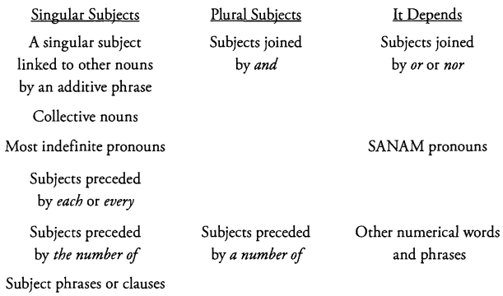

、平行
Arguably, the GMAT’s favorite grammar topic is parallelism. According to the principle of parallelism, comparable sentence parts must be structurally and logically similar.
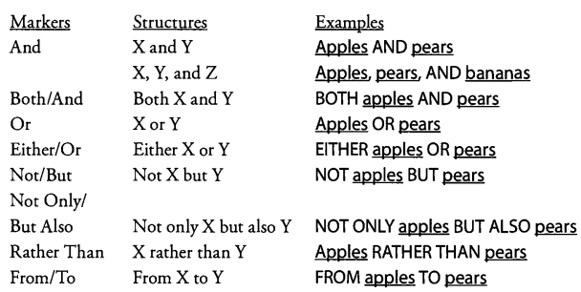
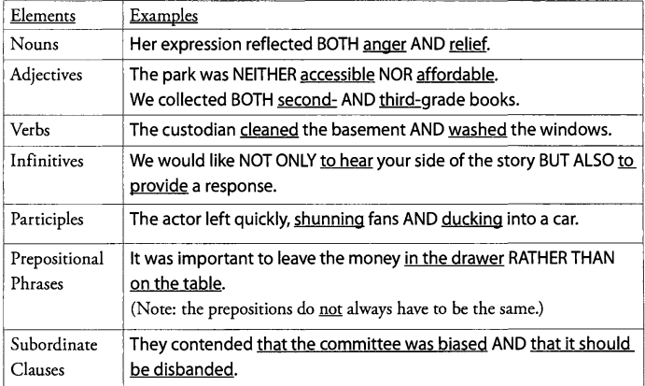

Two parallel clauses often both start with subordinators in order to remove ambiguity.
Wrong: I want to retire to a place WHERE I can relax AND I pay low taxes.
Right: I want to retire to a place WHERE I can relax AND WHERE I pay low taxes.

Without the repetition of the subordinator where, the first sentence could be read I want to retire... And I pay low taxes. Repeating the where eliminates ambiguity. The subordinators do not have to be identical.
Right: There are many people WHO speak English BUT WHOSE parents do not.

- Lists with And
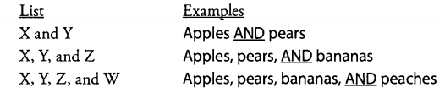

- Idioms with Built-In Parallel Structure
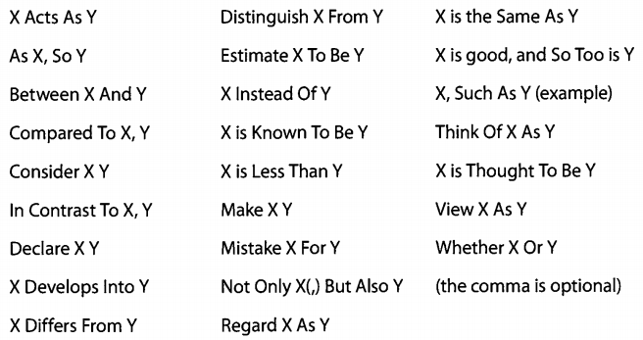

- Superficial Parallelism vs. Actual Parallelism
You always must figure out which grammatical structures are logically parallel before making them structurally parallel. Be particularly careful with verbs and verbal forms.

Sal applied himself in his new job, arriving early every day, skipping lunch regularly, AND leaving late every night.

In the sentence above, the -ing participle phrases arriving early every day, skipping lunch regularly , and leaving late every night are parallel . The main clause, applied himself in his new job, is not parallel to these participle phrases. This is CORRECT. The main verb is applied , and the -ing phrases provide additional information about how Sal applied himself. It would distort the meaning to change the sentence to this superficially parallel version:

Wrong: Sal applied himself in his new job, arrived early every day, skipped lunch regularly,
AND left late every night.

This version gives all the activities equal emphasis, instead of making the last three activities subordinate to the main activity (applied him self in his new job).
Do not assume that all verbs and verbal forms in a sentence must be parallel.

- Watch Out for Linking Verbs
Instead of expressing what a subject does, these verbs express what the subject is, or what condition the subject is in.

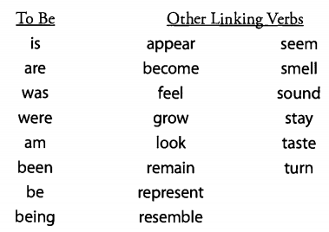
Treat any linking verb as a parallel marker. Make the subject and the object parallel

Wrong: The bouquet of flowers WAS a giving of love.
Right: The bouquet of flowers WAS a gift of love.

Wrong: Upon being nominated, this politician REPRESENTS a step forward in
urban-rural relations in this country.
Right: The nomination of this politician REPRESENTS a step forward in urban-rural relations in this country.

、代词
Pronoun errors are so frequent on the GMAT that every time you see a pronoun, such as it, its, they, them, or their, you should be sure to check whether it is being used correctly.

The first question you must ask yourself is this: What is the antecedent of this pronoun? Once you have found the antecedent, you must make sure that it makes sense and that it agrees in number with the pronoun. Ideally, the match between the antecedent and the pronoun should not be ambiguous, either.

- The Antecedent Must Exist
The park rangers discussed measures to prevent severe wildfires, which would be devastating to IT.
What noun does it refer to? We might guess the park. However, you should note that in this sentence, park is not truly a noun. Rather, park is acting as an adjective in the phrase the park rangers. As a result,park cannot be the antecedent of it.Moreover, there is no other possible antecedent in the sentence. Thus, as written, this sentence is incorrect.
Right: The rangers discussed measures to prevent severe wildfires, which would be devastating to THE PARK.
The antecedent to which you want to refer must actually exist in the sentence as a noun.

- The Antecedent & Pronoun Must Make Sense Together

- The Antecedent & Pronoun Must Agree in Number
the number of the pronoun must match the number of its antecedent.

- The Deadly Five: It, Its, They, Them, Their
The most common pronoun mistakes involve Third Person Personal Pronouns— the singular it and its,together with the plural they, them, and their. Whenever you see one of these five pronouns, find the antecedent and check its viability (“is the antecedent sensible and in agreement with the pronoun?”).

- This, That, These，and Those
>The Demonstrative Pronouns are this, that, these, and those. You may use any of these pronouns as adjectives in front of nouns, as we have already seen.
New "nano-papers" incorporate fibers that give THESE MATERIALS strength.

>You may also use that or those to indicate a “New Copy” or copies of the antecedent.
The money spent by her parents is less than THAT spent by her children.

In this example, that spent by her children means the money spent by her children.
Note that the two pots of money are NOT the same. One pot of money is spent by the parents; another pot of money, spent by the children, is the New Copy.
In contrast, when you use it, they, or other personal pronouns, you mean the same actual thing as the antecedent.

If you must change number, repeat the noun.
Wrong: Her company is outperforming THOSE OF her competitors.
Right: Her company is outperforming THE COMPANIES OF her competitors.

- What About Pronoun Ambiguity?
In theory, every pronoun in a well-written sentence should clearly refer to one antecedent. In particular, every it and its in one sentence must refer to the same singular antecedent.Likewise, every they, them ,and their must refer to the same plural antecedent. Otherwise, unacceptable confusion reigns.

If the intended antecedent of a single pronoun is clear (e.g., by virtue of parallelism and meaning), and if there is no other reasonable antecedent, then don’t worry if there is an unreasonable antecedent somewhere else in the sentence.

Right: Supernovas destroy their immediate environments in vast explosions, but by synthesizing heavy chemical elements, THEY provide the universe with the possibility of biochemistry-based life as we know it.

Supernovas is the subject of the first clause. The they is also in subject position in the second clause, which is parallel to the first clause. Even though there are at least two closer possible antecedents (environments and explosions), you know that they clearly refers to supernovas. The GMAT would consider this sentence acceptable.

you should note that nouns in the possessive case (with ‘s or s’) are often poor antecedents
Wrong: The board is investigating several executives' compensation packages in order to
determine how much may have been improperly awarded to THEM.
Right: The board is investigating the compensation packages of several executives in order to determine how much THEY may have been improperly awarded.

The GMAT would consider the previous sentence correct. If you really want to avoid any trace of ambiguity, replace they with a noun phrase such as these executives:
Right: The board is investigating the compensation packages of several executives in order to determine how much THESE EXECUTIVES may have been improperly awarded.

Every it and its must refer to the same singular antecedent. Every they, them,and their must refer to the same plural antecedent. These specific rules are respected on Sentence Correction.
Otherwise, don’t apply pronoun ambiguity unless you are backed into a corner. If you are down to two answer choices that are absolutely identical, except that one has they (referring to executives earlier) and the other has these executives, go with the latter, just to be super-safe.

、修饰
>A modifier describes or “modifies” someone or something in the sentence. Although modifiers can be as simple as a single word (an adjective or an adverb), GMAT sentences often contain several complex modifiers.
>Many modifying phrases in GMAT sentences are separated by commas from the noun being modified.

- Adjectives and Adverbs
An Adjective modifies only a noun or a pronoun,
whereas an Adverb modifies almost anything but a noun or a pronoun

The SMART student works QUICKLY.
Here the adjective smart modifies the noun student , while the adverb quickly modifies the verb works.
Many adverbs are formed by adding -ly to the adjective.
Amy is a GOOD person. {Good is an adjective that modifies the noun person.)
Amy is feeling GOOD. {Good is an adjective that modifies the noun Amy.)
Amy is feeling WELL. {Well is an adjective that modifies the noun Amy.)
Amy writes WELL. {Well is an adverb that modifies the verb writes.)
Often, the GMAT provides two grammatically correct phrasings.
For instance, one phrasing might be [Adjective + Adjective + Noun], in which the two adjectives both modify the noun.
The other phrasing would be [Adverb + Adjective + Noun], in which the adverb modifies the adjective, which in turn modifies the noun.
These two phrasings do not mean the same thing. Pick the phrasing that reflects the authors intent.

Wrong: James Joyce is Max's SUPPOSEDLY Irish ancestor.
Right: James Joyce is Max's SUPPOSED Irish ancestor.

James Joyce may or may not be M ax’s ancestor, but James Joyce was certainly Irish. Thus, we want the adjective supposed , so that we can modify the noun ancestor.

Wrong: Max's grandmother is his SUPPOSED Irish ancestor.
Right: Max's grandmother is his SUPPOSEDLY Irish ancestor.

What is in question here is whether M ax’s grandmother was Irish, not whether she is Max’s ancestor.
Thus, we want the adverb supposedly, so that we can modify the adjective Irish.

- Noun Modifiers
Phrases or clauses that modify nouns or pronouns are called Noun Modifiers. Noun modifiers act like long adjectives. The first word or two of a noun modifier determines its type, as seen in the chart below.
The modifier and the modified noun are both underlined.
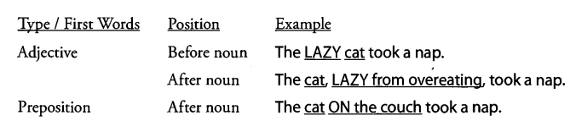

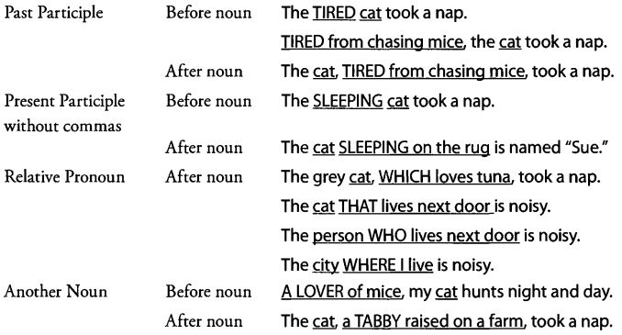

A noun used to modify another noun is called an Appositive. In the last example, the appositive noun tabby was itself modified by a past participle modifier {raised on a farm).Even modifiers of moderate length (a tabby raised on a farm) can contain other modifiers.

★Position of Noun Modifiers
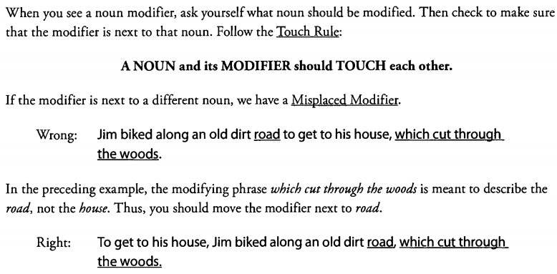
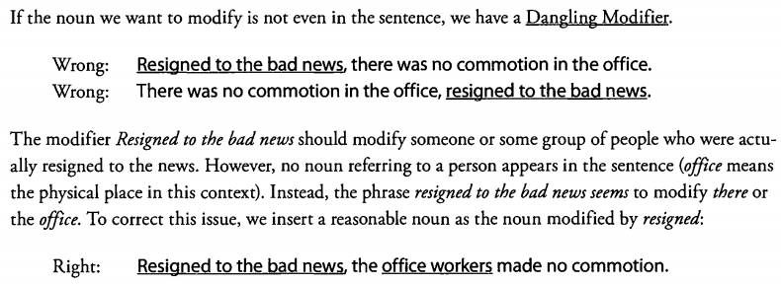
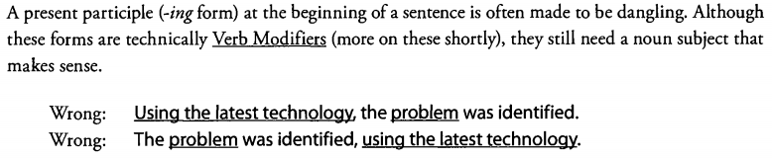
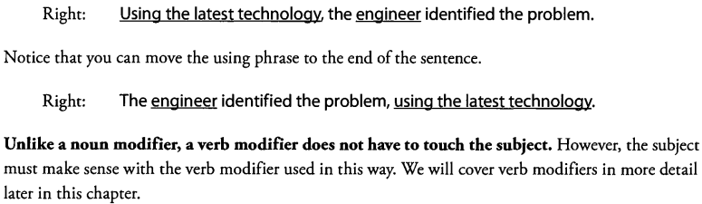
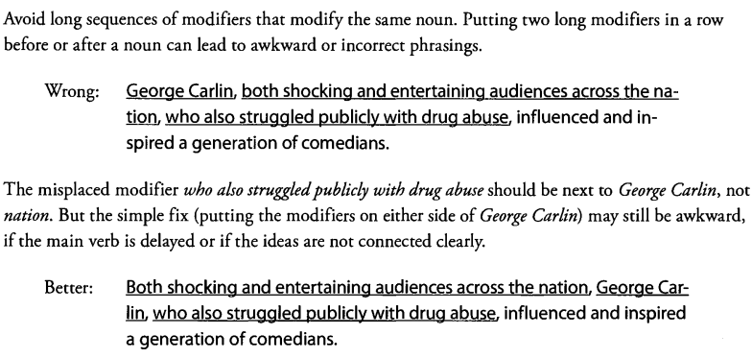
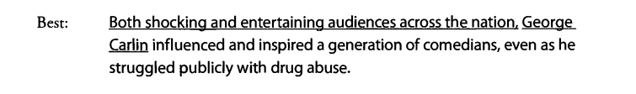

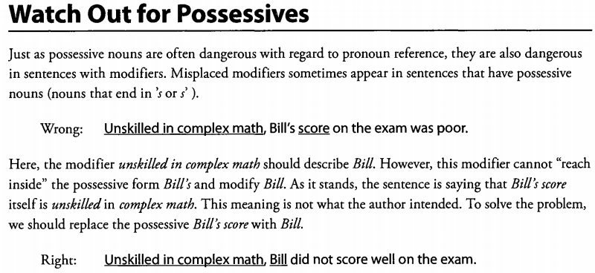
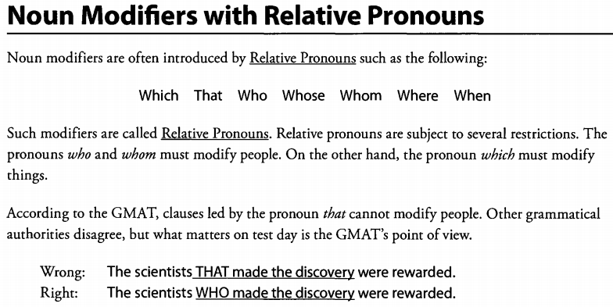
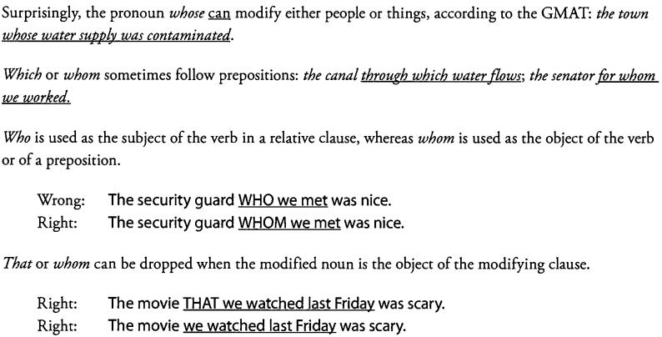
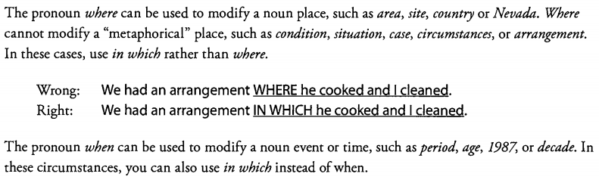

- Essential vs. Non-Essential Noun Modifiers
简单的说，限定性修饰就是必不可少的。非限定性修饰就是可有可无的，一般由逗号隔开。
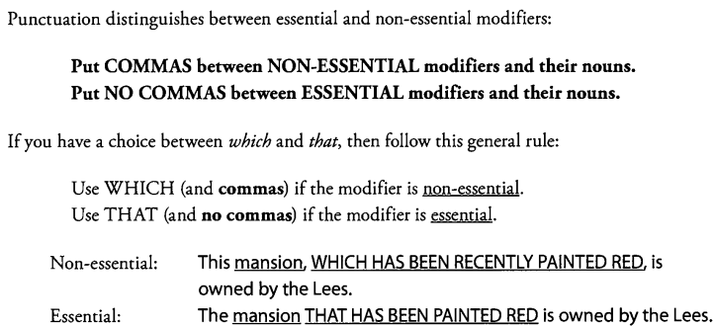
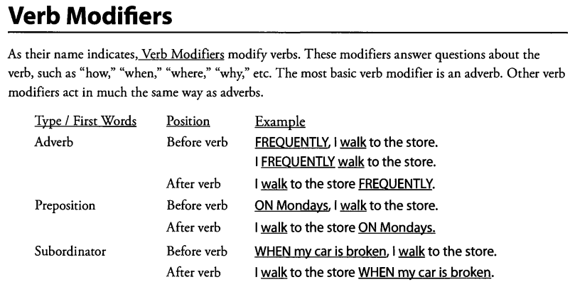
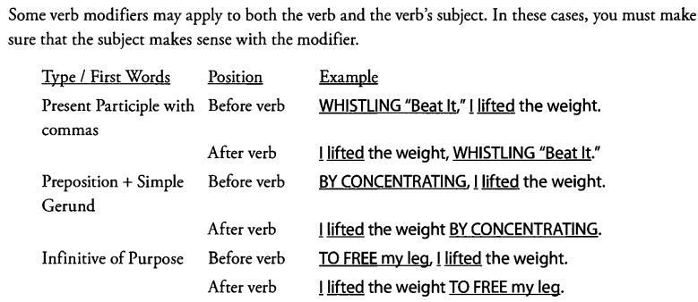
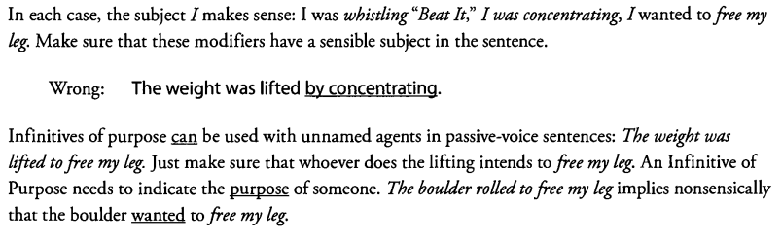
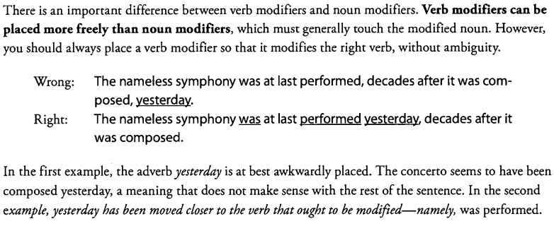
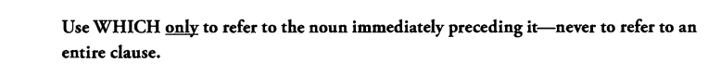
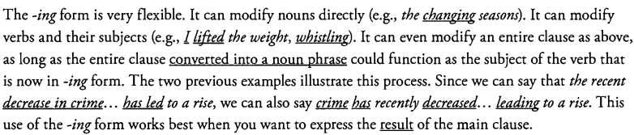

、动词的时态、语气和表达
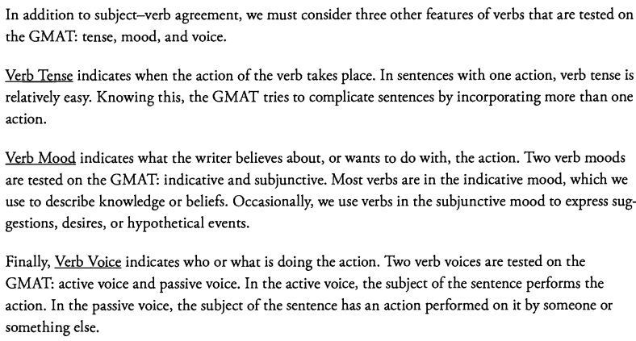

(1)The Simple Present tense is often used to express “eternal” states or frequent events
The GMAT typically prefers the simple tenses, unless the sentence clearly requires one of the more
complex tenses discussed below.

(2)To emphasize the ongoing nature of an action, we can use the Progressive tenses, which use the verb tobe and the present participle (-ing form)
>The Present Progressive indicates action happening right now, whether the sentence contains words
such as right now or not.
>Verbs that express general states do not normally take progressive forms. Such State Verbs include know
or signify.
Wrong: This inscription IS SIGNIFYING the emperor's birth.
Right: This inscription SIGNIFIES the emperor's birth.

(3)in some sentences the author clearly wants to talk about different periods of time. The tense should change to reflect that intention.
Right: He IS thinner now because he WENT on a strict diet six months ago.

In a more subtle example, you can use the Past Progressive to describe a background event, while you use Simple Past to describe a more important event in the foreground.
Right: She WAS PLAYING with her friends when the babysitter ARRIVED.
In the previous example, the action was playing (in the Past Progressive) takes place in the background.
Arrived (in the Simple Past) is the interrupting foreground event.

Note that the following sentence is also correct, but it has a different meaning.
Right: She PLAYED with her friends when the babysitter ARRIVED.
In this case, the action played took place after the babysitter arrived. Both actions are in the Simple Past
and e press equal levels of importance.

In the final answer you choose, make sure that every verb’s tense clearly represents the author’s intention.
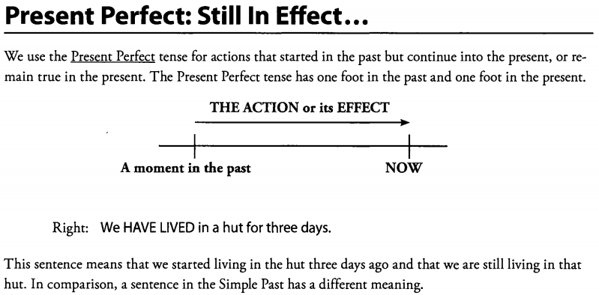
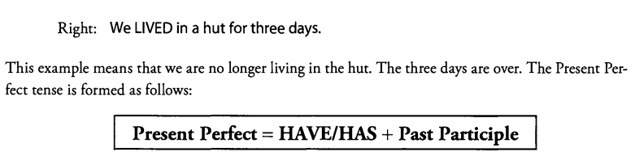

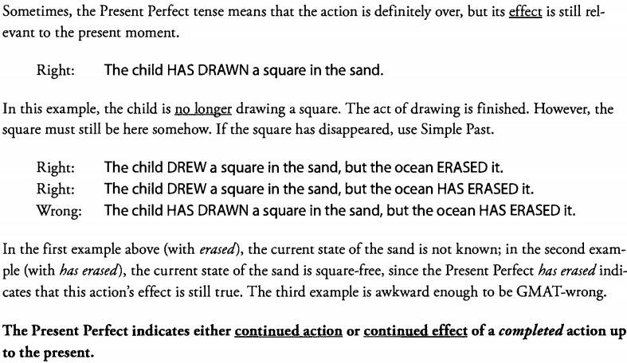
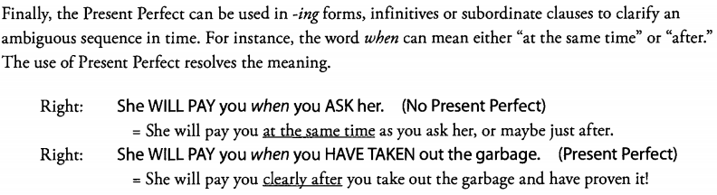
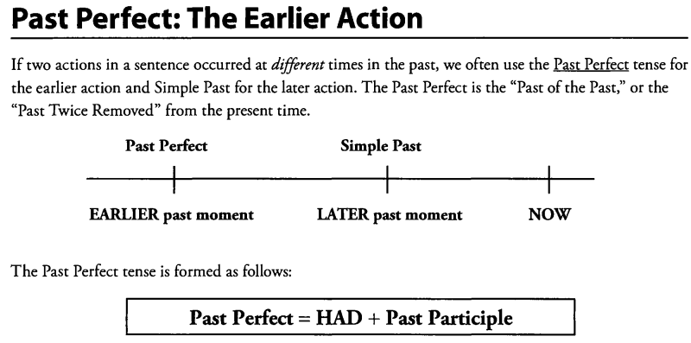

The earlier past action (had started, had cheated) is in the Past Perfect tense, while the later past action is in the Simple Past tense ( arrived , thought ).
Do not use Past Perfect simply for “long ago” without a later past moment. Even a long-ago moment can be referred to with Simple Past:
An asteroid STRUCK the earth millions o f years ago.

you can even make a tricky sentence in which the first clause expresses an early action in Simple Past. Then, a second clause expresses a later action in Past Perfect to indicate continued effect (by a still later past time).
Right: The band U2 WAS just one of many new groups on the rock music scene in the early 1980's, but less than ten years later, U2 HAD fully ECLIPSED its early rivals in the pantheon of popular music.

Do not use the perfect tenses when the simple tenses w ill do. The GMAT prefers simplicity.
Wrong: Joe LEARNED about an epoch in which dinosaurs HAD WALKED the earth.
Right: Joe LEARNED about an epoch in which dinosaurs WALKED the earth.

In the first example, the Past Perfect had walked is unnecessary. Although the action had walked does
take place earlier than the action learned , the earlier action does not have a direct bearing on the context
of the later action. The sequence of time does not need to be clarified or emphasized. Thus, the Past
Perfect is considered wrong in this context.

You should use the perfect tenses only when you can justify them with the rules described in these sections.
>If an action began in the past and continues into the present (or its effect does), use the Present Perfect tense. >If one action in the past precedes another, and you need to clarify or emphasize the time sequence, then use the Past Perfect tense.
Otherwise, stick to the simpler tenses.

MOOD
In English, most sentences express facts with the Indicative Mood or commands with the Imperative Mood. You can expect to see the Subjunctive Mood in two special situations:
(1) Unlikely or unreal conditions (usually after i f on a similar word).
(2) Proposals, desires, and requests formed with certain verbs and the word that.
These two uses correspond to two forms of the subjunctive mood: the Hypothetical Subjunctive and
the Command Subjunctive.

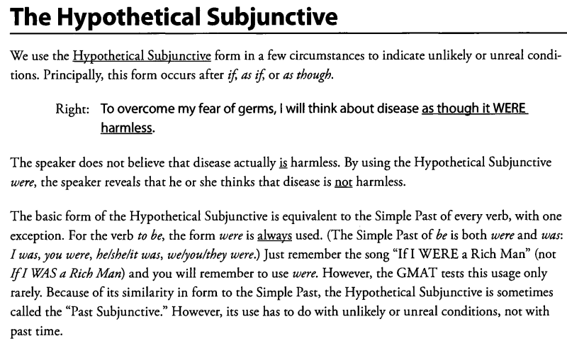
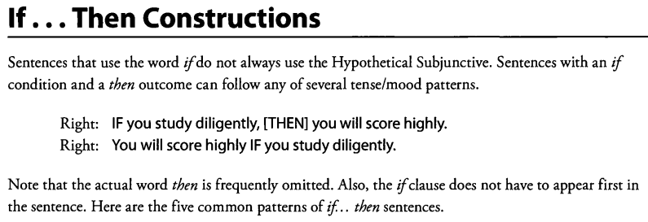
If…then….常见的五种句型(then 经常会被省略掉)
1.表示确定: If present, then present
EG: if she eats pizza, (then)she becomes ill.

2.表示某种程度的不确定: if present, then can or may
If she eats pizza, (then)she may become ill.

3.确定-用于将来时态：if present, then future
If she eats pizza tomorrow, (then)she will become ill.

4.不确定-现在时态：if hypothetical subjunctive, then conditional
If she ate pizza tomorrow, (then)she would become ill. (使用虚拟语气)

5.从未发生-过去式：if past perfect, then conditional perfect
If she had eaten pizza yesterday, (then)she would have become ill.(使用虚拟语气)
COMMAND SUBJUNCTIVE
The Command Subjunctive is used with certain Bossy Verbs, such as require or propose.
Bossy Verbs tell people to do things.
命令性的虚拟语气
1.一般形式： 主语+命令性词汇+that+从句主语+动词原形+…
2.常见的命令性词汇：demand, dictate, insist, mandate, propose, recommend, request,
stipulate, suggest
3.另外有些词汇，只能用不定式的：advise, allow, forbid, persuade, want
4.有些词汇既可以表示命令，又可以接不定式：ask, beg, intend, order, prefer, urge, require
5.具有命令性的词汇的名词形式同样应用虚拟语气
6.形容词性的命令词汇既可用虚拟语气，也可用不定式：如essential, advisable, crucial,
desirable, fitting, imperative, important, mandatory, necessary, preferable, urgent, vital
7.例外：prohibit
常见用法：prohibit sth；prohibit from doing；prohibit sb from doing
但prohibit不能接不定式
EG: In an attempt to guarantee the security of its innovative water purification method, the
company required each employee to sign a confidentiality agreement prohibiting disclosure of its
water purification methods to any company using an analogous purification process.
----------摘自manhattan翻译
Active and passive voice
Use by only for the actual doers of the action.
Wrong: News of the moon landing repeated around the world BY people of all ages, all races, and all religions.
Right: News of the moon landing WAS repeated around the world BY people of all ages, all races, and all religions.
Use through or because of when you want to describe any instrument or means, which might be an awkward or nonsensical subject in active voice.
Wrong: The pizza WAS accidentally EATEN BY a quirk of fate.
Wrong: A quirk of fate accidentally ate the pizza.
Right: THROUGH a quirk of fate, the pizza WAS accidentally EATEN.

Is Passive Voice Ever the Correct Answer?
The answer is YES, quite often! Voice is a matter of choice. Passive is sometimes longer or more awkward but still grammatically correct.

Passive: It HAS BEEN DECIDED by Jason that he will not attend college next fall.
Active: Jason HAS DECIDED next fall not to attend college.
The future time phrase next fall must stay away from the Present Perfect verb has decided.The active version has an illogical, incorrect meaning. But if you focus on the verb voice, you could miss this fundamental issue and pick the concise, active, but wrong answer choice.

Don’t be biased against the passive. Don’t use voice to eliminate answers, except for the clearly incorrect issues indicated on the previous page. In fact, if you must resort to guessing between an active and a passive choice, with absolutely nothing else to go on,
pick passive.You probably missed an error somewhere else in the active choice!

By the way, the passive voice is not always ugly. Sometimes its even stylistically preferable.
Right: During the operation, new blood vessels are inserted around blockages.

The passive voice is actually ideal here, as the writer intends to de-emphasize the surgeon and to emphasize the action performed on the blood vessels. The person performing the action, the unmentioned surgeon, is not important.
As a final note, you do not have to make active or passive voice parallel throughout a sentence.
Right: The shuttle launch TOOK place flawlessly and WAS SEEN on television.

第八章、比较
Comparisons are a form of parallelism that deserves special attention. As the name indicates, comparisons compare two parts of the sentence (or occasionally more).

1)Like/ As
Like is a preposition. This means that LIKE must be followed by nouns, pronouns, or noun phrases.
Never put a clause or a prepositional phrase after like (Remember, a clause contains a working verb, one that can be the main verb in a sentence.) You can correctly use like to compare two nouns.
Consider the following example:
Right: LIKE her brother. Ava aced the test.
as can be either a preposition (appearing with a noun) or a conjunction (appearing with a clause). You can correctly use as to compare two clauses. Again, however, you cannot use like to compare clauses.
Wrong: LIKE her brother DID, Ava aced the test.
Right: AS her brother DID, Ava aced the test.
The words her brother did form a clause (did is a working verb). Therefore, you must use as to make the comparison between the two clauses Ava aced the test and her brother did.
Using like to compare clauses is common in speech but always wrong in writing.
Keep Comparisons Parallel！
>Comparisons must be logically parallel. That is, they must compare similar things
>Comparisons must be structurally parallel. That is, they must have a similar grammatical structure.
I like to run through forests more than I enjoy walking through crowds.

Are the objects of comparison grammatically parallel? No, because to run through forests does not have the same structure as walking through crowds. To run is an infinitive, whereas walking is a gerund (walking is being used as a noun). To write a concise, parallel sentence, we should simply use one verb (like)and convert both objects to -in g forms.

Right: I like running through forests MORE THAN walking through crowds.

1、对主谓宾全的句型
(1)主语比较：A do sth than B do.（AB为对等名词，加do 是为了显示这是一个可以发出动
作的名词，因而确定是主语，进而确定是主语对比）
(2)介宾比较A do sth of C1 by D1 than of C2 by D2.（C1C2，D1D2对等名词）
注意一定要是介宾才能直接跟在than后面
The clothes inside the store looked more appealing than outside the racks. 错,不是介宾比较
The clothes inside the store looked more appealing than did those outside the racks. 对
(3)宾语比较A do C1 than C2.(C1C2为对等名词）
(4)状语比较A do sth than usual/ever before/people expected(直接加状语）

- 、习惯搭配（略）

、零碎知识

1）Connecting Words
A comma is not enough to join two main clauses. A sentence that violates this rule is called a Run-on Sentence.

The conjunctions and, but, and or are very common connecting words. These three words, along with for, nor, yet, and so, are also called Coordinating Conjunctions. Together with a comma, a coordinating conjunction can link two main clauses to form a grammatical sentence.

Subordinators are another kind of connecting word. Subordinators, such as because and although, create subordinate clauses, which can in turn attach to a main clause with a comma.
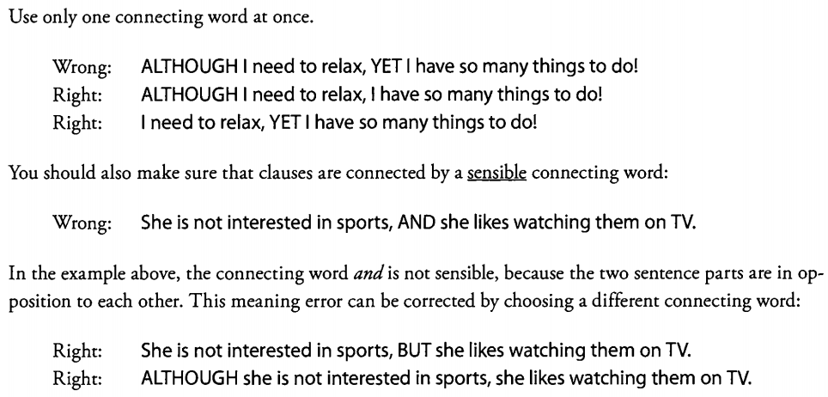

The following is a list of common connecting words:
Coordinating Conjunctions: For And Nor But Or Yet So
Subordinators: Although Because Before After Since When If Unless That Though While
Be sure to choose a connector that logically fits into a given sentence

2）connecting punctuation
1、逗号
(1)次要内容会用逗号隔开，但是主要内容和主句一脉相承。（插入语）
(2) 一个主语发出的两个动词间的and不用逗号。
EG: Wrong: Earl walked to school, AND later ate his lunch.
Right: Earl walked to school AND later ate his lunch.
(3) 逗号不能连接两个完整的句子。（老生常谈）
2、分号
(1)分号用以连接两个紧密相关的句子， 这两个句子又是分别相对完整的句子。 （说是“相对”，是因为虽然语法上都能单独成句，但是逻辑意思上第二句单独出来的话就说不通）
EG: Andrew and Lisa are inseparable; they do everything together.
(2)用分号连接的两句应该是独立、平衡的。如果原句有从属关系，那么应该保留。
(3)分号后经常跟一些链接副词（注意这些词不是真正的连词，不能用逗号替代分号），如
however, therefore, in addition, then.（连接副词：这类副词有相当于并列连词的therefore, besides, otherwise, however, moreover, furthermore, still, thus, meanwhile等）
EG: Wrong: Andrew and Lisa are inseparable, THEREFORE, we never see them apart.
Right: Andrew and Lisa are inseparable; THEREFORE, we never see them apart.
(4)分号还有个主要的用法：用来隔开带逗号的一串名词。
EG: Wrong: I listen to Earth, Wind & Fire, Wow, Owls, and Blood, Sweat & Tears.
Right: I listen to Earth, Wind & Fire;Wow, Owls; and Blood, Sweat & Tears.
3、冒号
(1)冒号是对前面提出的信息起补充说明作用，可以在冒号后面加namely或者that is。
(2)冒号前的分句必须能够单独成句，冒号后的则不一定。
(3)被解释的成分与冒号后的解释成分越近越好。
EG: The rate of a reaction is affected by three factors: concentration, surface area, and
temperature.
(4)冒号后可以加入一个主句，用以解释冒号前的内容。
EG: On January 1, 2000, the national mood was completely different from what it would become
just a few years later: at the turn of the century, given a seemingly unstoppable stock market and a
seemingly peaceful world, the country was content.
4、破折号
(1)破折号的用法很富有弹性，既可以作强调作用，也能充当冒号，分号。
(2)有时候为了突出主要内容或者解释时，破折号更佳。
EG: My three best friends-Danny, Jimmy, and Joey-and I went skiing. (用逗号意思就变7个人了)
(3)破折号还可以重复或者解释前半句的内容。但又和冒号不同，破折号不一定立刻放在被
解释内容之后。
EG: Post-MBA compensation for investment bankers tends to surge far ahead of that for
management consultants-by tens, if not hundreds, of thousands of dollars a year.
(4)用的比较广泛，破折号有双的，也有单的

Quantity
1、可数的量词：few、number、numerous
2、不可数的量词：less、amount、great、least
3、既可跟可数名词又可跟不可数名词的量词：more, most, enough, all 但是less只能不可数
4、留意单数词：如money-dollar, volume-gallons, 这些单位词可用复数，但都是修饰不可数
名词的
- the number of 修饰单数，a number of 修饰复数，The numbers of 一般都是错的
如果要做比较，一般用greater than, 而不是more than
6、increase和decrease表达同一事物的变化；Greater和less则是比较不同事物。
7、在使用这些词的时候，要避免意思重复： Decrease-fall; increase-rise

TWICE

、简洁，主谓，平行（高阶）
- Concision: Specific Patterns of Wordiness
The GMAT prefers concise expressions to wordier ones. As you were warned in Chapter 2, this is only a preference. In fact, the GMAT w ill often make the less concise answer correct by putting a subtle error into the more concise choice. Since so many students over-apply the principle of concision, you’re better off putting any judgments about wordiness out of your mind until you’ve mastered the prior chapters.

here are rules of thumb that you can apply.
Here is how to rank parts of speech by “concision power”: drive the V-A-N.
V-A-N = Verb > Adjective (or Adverb) > Noun
An active Verb is usually stronger and more concise than an Adjective or an action Noun.
V-A-N Pattern 1; Prefer a Verb to an Action Noun
Wordy: The townspeople's REVOLUTION WAS AGAINST the king.
Better: The townspeople REVOLTED AGAINST the king.
V-A-N Pattern 2: Prefer a That-Clause (with Verbs) to a Series of Phrases (with Nouns)
Wordy: The hypothesis ABOUT the COMPOSITION OF the universe AS largely dark
energy seems strange.
Better: The hypothesis THAT the universe IS largely COMPOSED OF dark energy
seems strange.
V-A-N Pattern 3: Prefer a Verb to an Adjective
Wordy: The artist WAS INFLUENTIAL TO the movement.
Better: The artist INFLUENCED the movement.
V-A-N Pattern 4: Prefer an Adjective to a Noun
Wordy: THERE IS AN ABUNDANCE OF funds for school construction.
Better: Funds for school construction ARE ABUNDANT.
V-A-N Pattern 5: Prefer an Adverb to a Prepositional Phrase
Wordy: Oil prices have fallen, but prices at the gasoline pump have not fallen TO
A COMPARABLE EXTENT.
Better: Oil prices have fallen, but prices at the gasoline pump have not fallen
COMPARABLY.
Concision Pattern 6; Prefer an Adjective to an Adjective Clause with Be
Wordy: Marcos is a professor WHO IS ADMIRABLE.
Better: Marcos is an ADMIRABLE professor.
Concision Pattern 7: Remove IT IS... THAT...
Wordy: IT IS without fear THAT children should play.
Better: Children should play without fear.

★Concision: Don't Make It Too Short！
"Too Short" Pattern 1: Keep the Prepositional Phrase if You Need To
Too Short: I talked to the BOSTON SOLDIER.
Better : I talked to the SOLDIER FROM BOSTON.
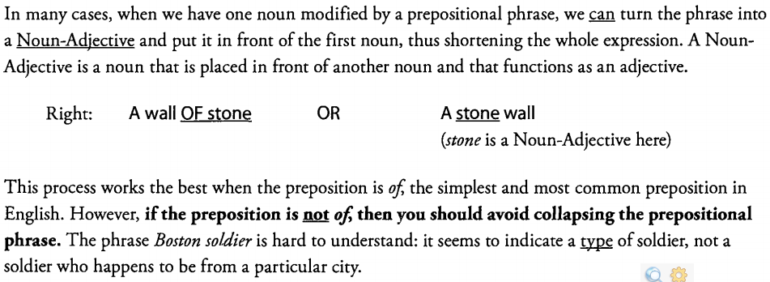
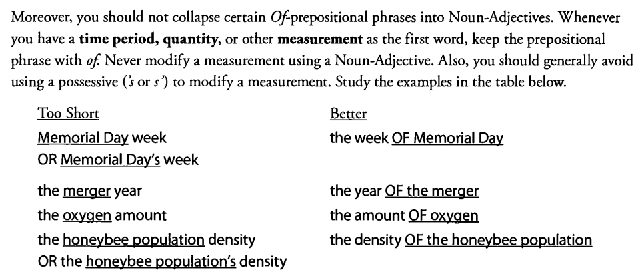
"Too Short" Pattern 2: Keep That Of or Those Of if You Need To
Too Short: The face I see in ads every day is a famous actor.
Better: The face I see in ads every day is THAT OF a fam
Note that the GMAT sometimes inserts an unnecessary that o fo t those o f which you do have to remove.
Wordy: The fields I most enjoy studying are THOSE OF physics and chemistry.
Better: The fields I most enjoy studying are physics and chemistry.
Physics and chemistry are in fact fields (of study), so you should simply say
The fields... are physics and chemistry.

"Too Short" Pattern 3: Keep That after a Reporting Verb
Too Short: The study INDICATES the problem has vanished.
Better: The study INDICATES THAT the problem has vanished.

A Reporting Verb, such as indicate, claim, contend,or report,often in fact reports or otherwise includes a thought or belief. This thought can stand alone as a sentence:
The problem has vanished.

If you drop the that,you might get confused for a moment as you read: The study indicates the problem .... At this stage, the author might be saying that the study simply points out the problem . To avoid the ambiguity, the GMAT prefers that you keep the that.
The GMAT insists that the following Reporting Verbs take that whenever you follow them with a clause (a thought expressed in its own mini-sentence).
Verb Better
Agree The criminals AGREED THAT gold would be the scam.
Claim They CLAIMED THAT gold was growing scarce.
Contend They CONTENDED THAT the price of gold would rise.
Declare They DECLARED THAT they had discovered gold.
Find Investors FOUND THAT they could not get answers.
Indicate An article INDICATED THAT the mine was worthless.
Reveal An investigation REVEALED THAT the gold was a mirage.
Rule The court RULED THAT the criminals were guilty of fraud.
Show This story SHOWS THAT crime does not pay.
It is likely that the GMAT w ill insist on that after most other Reporting Verbs. Other common Reporting Verbs include announce, assert, believe, confess, demonstrate, doubt, expect, hold, know, mention,observe, proclaim , reason, recognize, repeat, state, think,and warn , as well as various forms with the verb be,such as be convinced, be certain, be assured,and so forth.

The main exception to this pattern seems to be the verb say.Somewhat oddly, the GMAT does not require you to put that after the verb say.
Right: The water was so cold that people SAID polar bears would shiver.
The GMAT does not explain why this omission is acceptable, but the reason is probably that there is very little chance of confusion:

2)Parallelism: Concrete Nouns and Action Nouns
1. Concrete nouns refer to things, people, places, and even time periods or certain events.
rock, continent, electron, politician, region, holiday, week
2. Action nouns refer to actions, as their name implies. They are often formed from verbs.
eruption, pollution, nomination, withdrawal, development, change, growth
To maintain logical parallelism, avoid making concrete nouns and action nouns parallel.

A. Simple Gerund Phrases
Tracking satellites accurately is important for the space agency.
Simple gerund phrases are “Nouns on the Outside, Verbs on the Inside,” like some kind of crunchy grammatical cookie.
The underlined phrase acts as a noun:
Something is important for the space agency.
B. Complex Gerund Phrases
The accurate tracking of satellites is important for the space agency.
Complex gerund phrases are “Nouns Through and Through.” The -ing gerund form is made fully into a noun; in fact, it is often preceded by articles (a, any or the)or adjectives (accurate).The object is put into an Of prepositional phrase (e.g., the running o f marathons)or placed in front of the -ing form (e.g., marathon running). Complex gerund phrases may sometimes sound less natural than simple gerund phrases, as in the example above
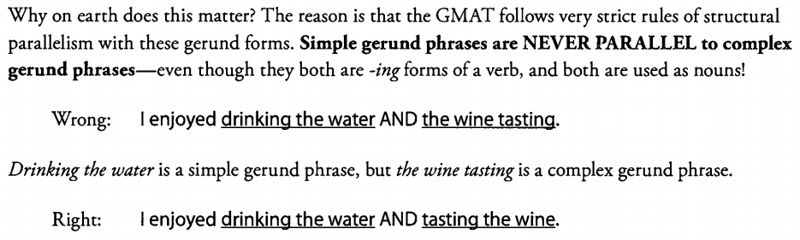
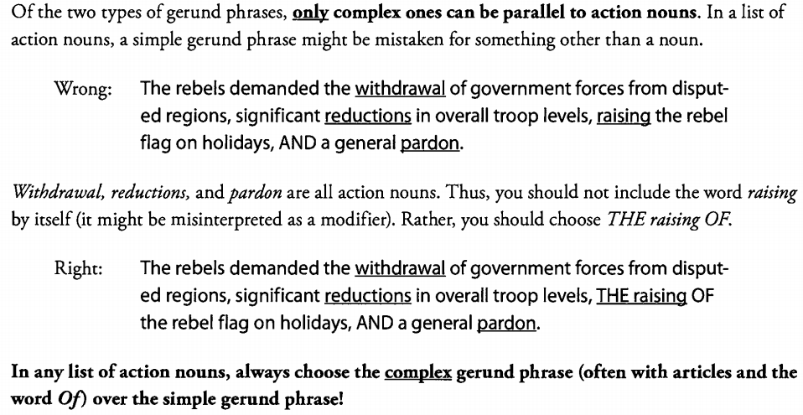
Also, if an appropriate action noun for a particular verb already exists in English, then avoid creating a
complex gerund phrase. Instead, use the pre-existing action noun.

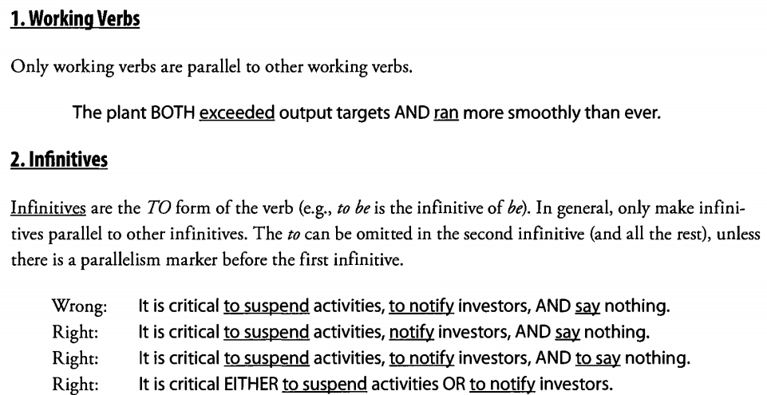
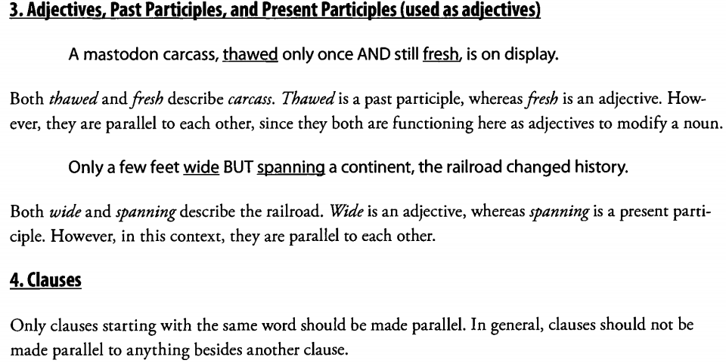

第十二章、介词和修饰（高阶）
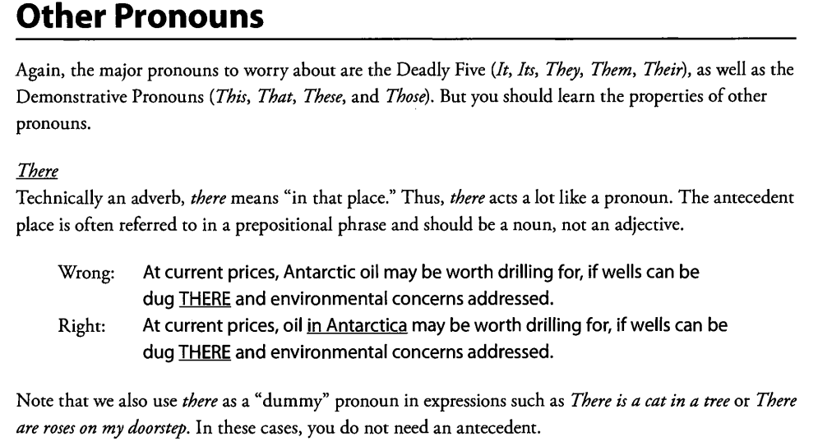
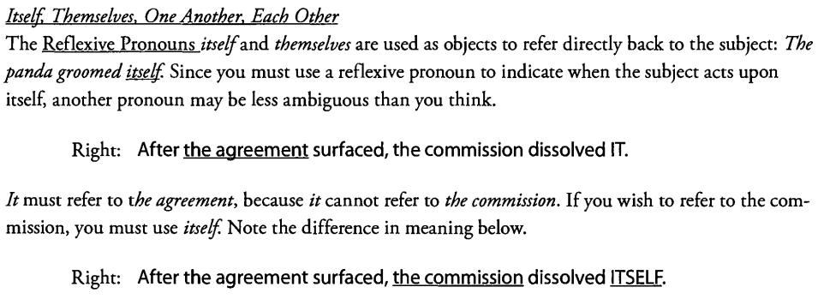
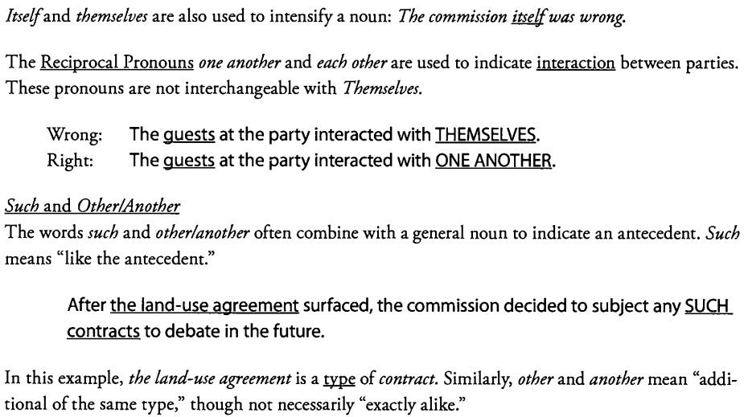
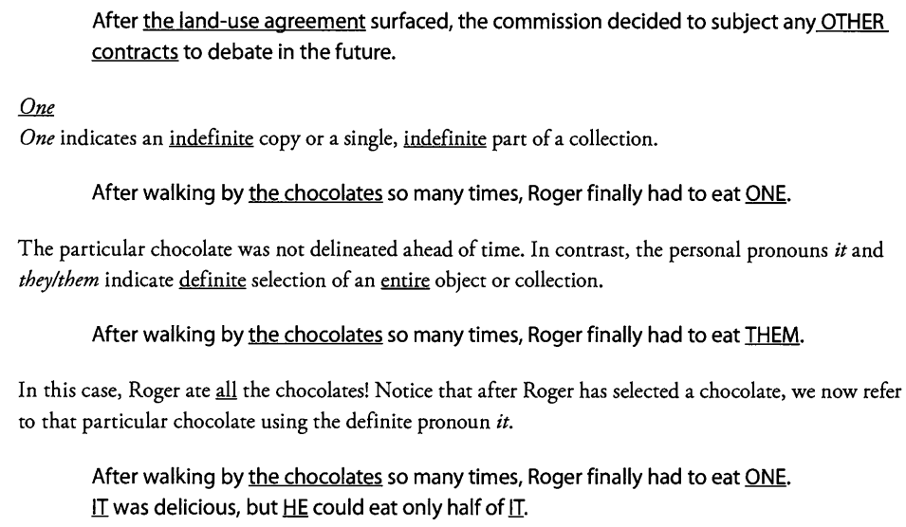

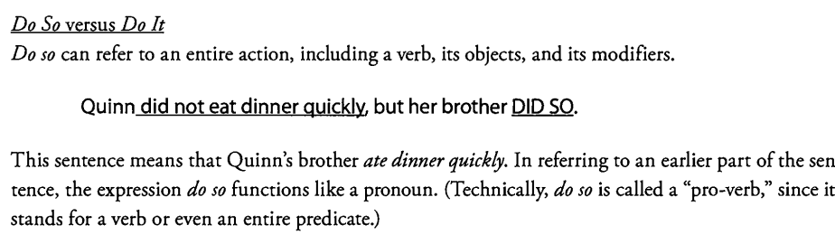
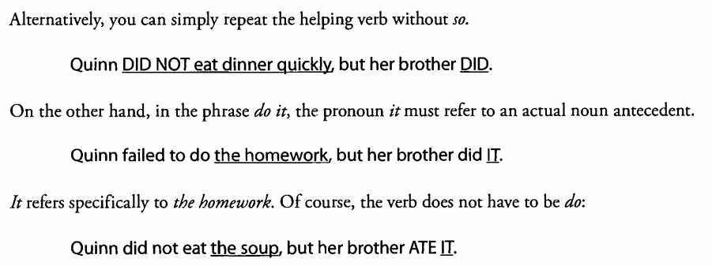

代词指代法则

1. Number The antecedent must agree in number (singular, plural) with the pronoun.
2.Gender The antecedent must agree in gender (masculine, feminine, neuter) with the pronoun.
3. Repeats Repeated pronouns are presumed to have the same antecedent.
The remaining two principles are not absolute.
- Proximity The pronoun should refer to the closest eligible antecedent.
Note that there is such an idea as “too close.” In the sentence In the station house IT is considered taboo, the IT cannot refer to station house. The antecedent normally occurs earlier in the sentence.
5. Case the pronoun and the antecedent should agree in case if they are in parallel structures.
In particular, a subject pronoun in one clause often refers to a noun in subject position
in another parallel clause. In general, subject nouns make strong antecedents, even for
somewhat distant pronouns.

Modifiers: Exceptions to the Touch Rule

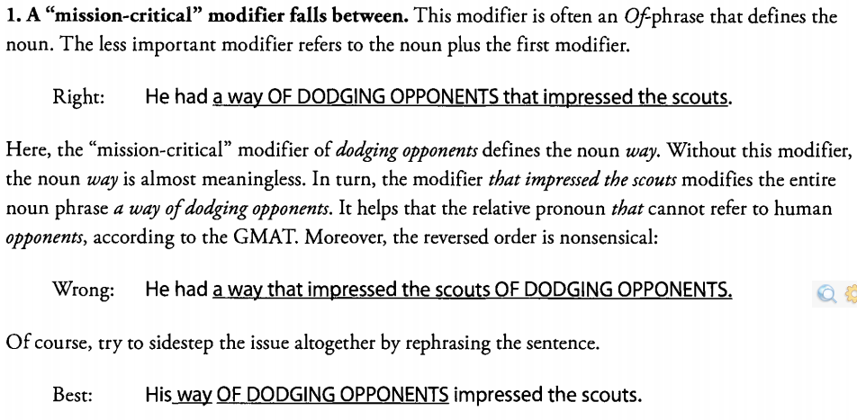
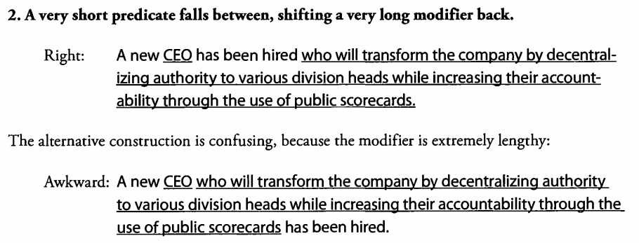
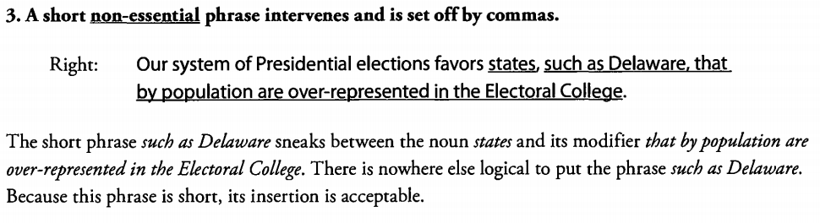

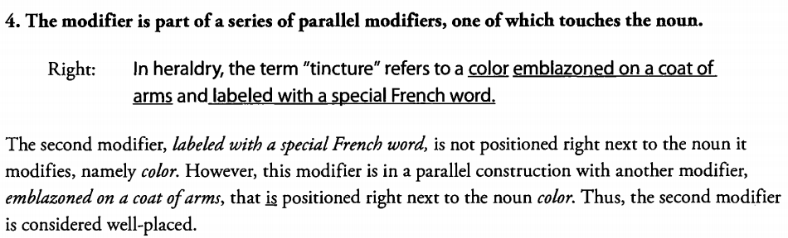

To summarize, noun modifiers must touch the modified noun, with a few minor exceptions. These
exceptions all “read” well; simply use your judgment as you apply the Touch Rule.

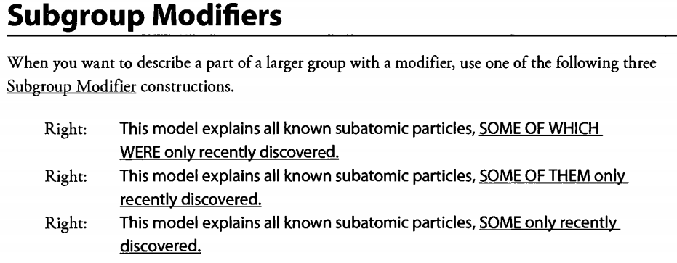
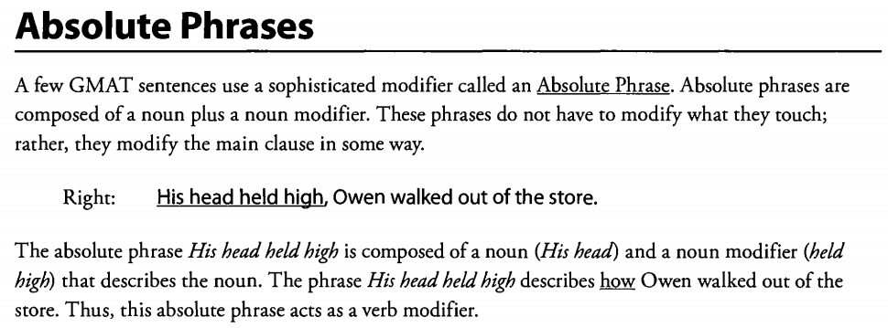

An absolute phrase is typically separated from the rest of the sentence by a comma. However, for an absolute phrase at the end of a sentence, you may also use a dash (—)

1)一般独立主格,与主句形成松散的逻辑关系，与主句描述动作、状态同时发生或存在，形式为:
n．+ n.; n. + -ed/ing 形式; n. + 介词短语;n. +形容词短语
- with 型独立主格,与主句形成紧密的逻辑联系.由“with＋宾语＋宾补”构成的复合结构，在句中可作状语，表示伴随，修饰邻近分句主语，with后面宾语为与主语相关的东西。
3)each型独立主格,强调句尾名词,形式为:
句子 + 复数名词结尾, each + 介词短语/形容词短语/-ed形式/-ing 形式

、动词与比较（高阶）
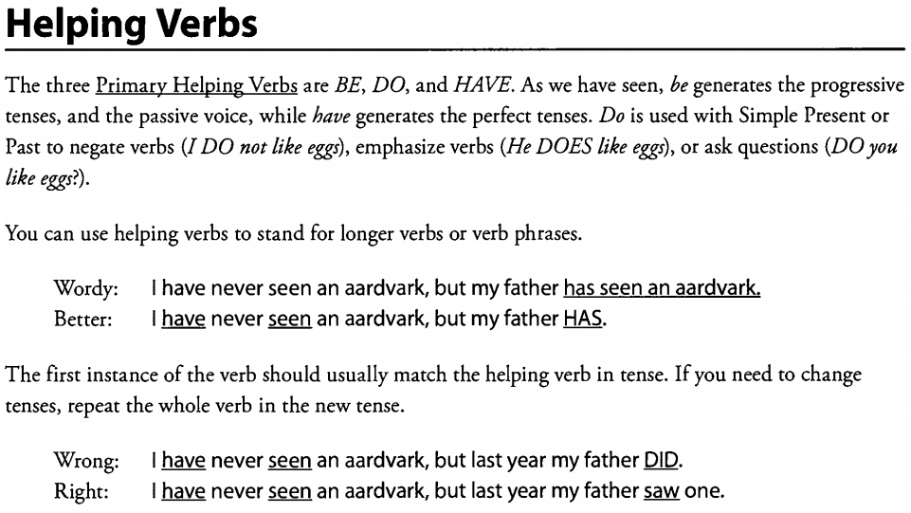
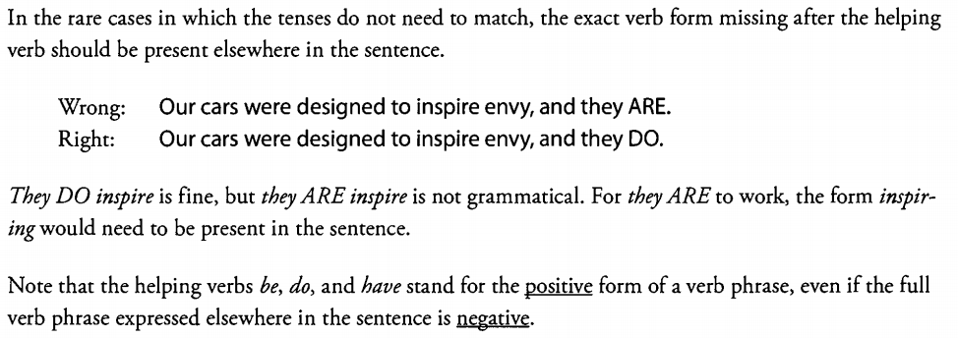

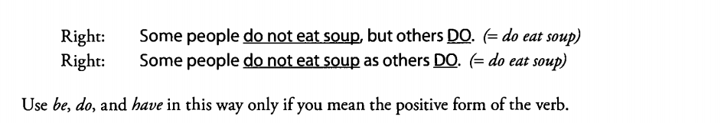
In addition to these three prim ary helping verbs, there are several Modal Helping Verbs. The principal modal helping verbs are can, could, may, might, must, shall, should, will,and would.As noted in Chapter 2, these verbs should not be used interchangeably.

Infinitives, such as to watch, to throw , or to see, are considered the “dictionary” form of the verb: the most basic version. Infinitives may serve as nouns, adjectives, or adverbs.
Noun: I love TO SWIM. To swim is the object of the verb love.
Adjective: The person TO MEET is here. To meet modifies the noun person.
Adverb: Sue paused TO EAT lunch. To eat modifies the verb paused.
Gerunds are -ing forms used as nouns. -ing forms are much more noun-like than infinitives. You can easily use them not only as objects of verbs, but also as subjects of verbs and objects of prepositions:
Subject of verb: SWIMMING is fun. Swimming is the subject of is.
Object of verb: I love SWIMMING. Swimming is the object of love.
Object of preposition: I dream of SWIMMING. Swimming is the object of of
Present participles are -ing forms used to modify nouns, verbs, or even whole clauses. By now, you should note that the -ing form can be used in many grammatical ways. In fact, there are four members of the “-ing Dynasty,” representing four key uses of the -ing form:
Verb (Progressive Tense) She is FIXING the faucet.
Noun (Gerund) FIXING the faucet is not fun.
Adjective (Present Participle) The person FIXING the faucet is tired.
Adverb (Present Participle) She crouched under the sink, FIXING the faucet.

In contrast, the past participle is typically used as part of a perfect-tense verb or as an adjective:
Verb (Perfect Tense) She has BROKEN the lamp.
Adjective (Present Participle) The BROKEN lamp is on the stairs.
An -ing form may be combined with a past participle: Having broken the lamp, she has been worrying all night.

一个容易弄错的比较：
关于twice as many/much as结构：
If you say "twice as many", then this construction should be paired with a countable noun.
e.g., twice as many dogs --> "dogs" is a countable noun
If you said "twice as much", then this construction should be paired with an uncountable noun.
e.g., twice as much water --> "water" is an uncountable noun
If the noun in question is already an explicitly numerical quantity, then you should use neither "much" nor "many". Instead, you should just use "twice" or "double" by itself.
e.g., twice the increase --> "increase" is an explicitly numerical quantity
These rules are followed pretty closely.
so, for instance:
twice as much water --> correct, since "water" is an uncountable noun (but is not an explicitly numerical quantity)
twice the water... --> incorrect, since water is not a numerical quantity
twice as much as the increase... --> incorrect; redundant
twice the increase... --> correct

Use times without as or than to indicate direct multiplication. ( Twice means two times!)
Right: The cost of a ticket is $12, SIX TIMES the cost ten years ago.
Right: The concert was attended by 300 people, TWICE the previous attendance.

Comparison As is the most important conjunction use of as on the GMAT. It sometimes appears together with just, so,or even so too.
Right: JUST AS the trains were late yesterday, the buses are late today.
Right: JUST AS the trains were late yesterday, SO TOO are they late today.

In numerical comparisons, the words high and low,as well as higher and lower,should only be used as adjectives.
Right: My bills are LOWER than they were last year.
Wrong: I spend LOWER than I did last year.
Right: I spend LESS than I did last year
The phrase in addition to is worth mentioning. At the beginning of a sentence, you can use this construction to add another example to the subject. You can also use it to add another example to a different noun in the sentence, such as the object of the verb or some other noun. This usage is endorsed by the GMAT.
Right: IN ADDITION TO taxes, death is inevitable.
Right: IN ADDITION TO Munster cheese. I like Swiss.
Put more and less in the right positions. Watch out for ambiguity, especially when more comes before an adjective plus a noun.
We have even MORE efficient engines than before.
Does this sentence mean that we have a greater quantity of efficient engines? Or do we have engines that are more efficient? The right answer w ill resolve the ambiguity.
Right: We have even MORE engines that are efficient than before.
Right: We have engines even MORE efficient than before.

Occasionally, a less common comparison signal appears in a GMAT sentence. For instance, some verbs, such as exceed or surpass, indicate comparisons. As always, make sure that the two items under comparison are parallel.
Wrong: The incidence of the disease among men exceeds women.
An incidence cannot logically exceed women.In the construction X exceeds Y, the subject X and the object Y must be parallel. To fix the problem, you can repeat the noun incidence or use the pronoun that.
In any case, you must repeat the preposition among.
Right: The incidence of the disease among men EXCEEDS the incidence among women.
Right: The incidence of the disease among men EXCEEDS its incidence among women.
Right: The incidence of the disease among men EXCEEDS that among women.

补充一份 there be 的比较
There be 句型等同于一般的主谓宾俱全的句型
OG89
There is one PC for every 32 pupils in American four time as many as there were four years ago(主语比较)
There is one PC for every 32 pupils in American four time as many as DVD player(宾语比较)
There is one PC for every 32 pupils in American four time as many as for school teachers.(介宾比较)
There is one PC for every 32 pupils in American four time as many as in china(介宾比较)

重要的知识点：
【, V-ing】小结： A)逻辑主语=句子主语，此时表伴随动作 B)逻辑主语=主句全句，此时表结果状语 C)前方为主系表结构，不表伴随、不表结果，只是对前句的补充说明
如果产生了时间断层，绝对不可能伴随动作。【也应注意，出现过去和现在的情况，重点肯定是在现在的情况上
EG:Though called a sea, the landlocked Caspian is actually the largest lake on Earth, covering more than four times the surface area of its closest rival in size, North America’s Lake Superior.

Compare/ whereas/while
whereas/while这种连词连接的比较成分不要求含义上绝对的平行，具体见prep 1-211。
1) compared with直接跟在逗号后面可以修饰逗号前面名词短语的核心词：
Example：
In the United States, while the number of foreign-born residents and their children is higher than ever, the percentage of the population they represent is not; in 1910 this group made up 35 percent of the population, compared with 20 percent in 2000.
2) Compared with也可以修饰前面整个分句，compared with后面的名词与主语比较：
Example:
Today, more than 43 percent of Californians under the age of eighteen are Hispanic, compared with about 35 percent a decade ago.
In the United States, Fifty-two percent of high school graduates go on to college, compared with thirty-five percent in Canada and fifteen percent in Great Britain, Japan, and West Germany.
One baby in four is now born to a mother aged thirty or older, compared with just one in six in 1975.
3) as compared to/with中as指代前面整句的核心含义：
A recent review of pay scales indicates that, on average, CEO's now earn 419 times the pay of blue-collar workers, as compared to 42 times their pay, the ratio in 1980.

